PERSONAL READING & FOCUS ROOM BOOKER
@CREATIVITY THINK (9483175986/7019689991)

ABSTRACT:
Personal Reading & Focus Room Booker is a web-based system designed to enable efficient booking and management of silent rooms or study seats in libraries, study halls, and co-working spaces. The platform allows users to register, select rooms or seats, book time slots, check in/out, track focus hours, and view personal streaks along with a simple leaderboard. Administrators can define room rules, monitor bookings, release no-show seats, and analyze usage trends through charts and reports. Developed using Django and Django REST Framework for backend processing, and React with react-calendar and axios for frontend interactivity, the system ensures structured seat management, real-time booking visibility, and user engagement..

INTRODUCTION OF THE PROJECT:
Libraries and study halls often face challenges in managing room occupancy, preventing double bookings, and ensuring efficient utilization of seats. Manual booking or first-come-first-serve approaches lead to conflicts and underutilization. Personal Reading & Focus Room Booker addresses these challenges by providing a centralized digital system for booking, tracking, and reporting seat usage. Users can easily schedule focus sessions, while administrators gain full control over room allocation, monitoring, and usage analytics, enhancing both operational efficiency and user experience..

PROJECT OBJECTIVES:

• Provide a secure platform for booking silent rooms or study seats
• Allow users to register, select rooms, and book specific time slots
• Enable check-in and check-out tracking for accurate usage logging
• Display personal focus hours, streaks, and a simple leaderboard
• Allow administrators to define room and seat rules
• Monitor active bookings and enforce no-show release policies
• Provide analytics dashboards for peak hours, occupancy trends, and usage patterns
• Support report generation and export of booking logs
• Ensure scalable backend services and responsive frontend interface

PROBLEM OF THE STATEMENT:
Libraries, study halls, and co-working spaces often lack an organized system to manage room and seat bookings. Traditional manual booking methods or ad-hoc scheduling create conflicts, inefficient usage, and no transparency on usage patterns. Users cannot track their focus sessions, and administrators cannot generate accurate reports. Personal Reading & Focus Room Booker solves these problems by providing a structured, digital solution for booking, tracking, analytics, and reporting..

MOTIVATION OF THE PROJECT:
• To digitalize room and seat booking in libraries and co-working spaces
• To prevent double-bookings and optimize space utilization
• To track user focus hours and encourage consistent study habits
• To provide administrators with real-time monitoring and analytics
• To enable timely release of unoccupied seats
• To generate actionable insights for room management
• To enhance user engagement through streaks and leaderboard
• To create a scalable, responsive, and user-friendly booking platform

BLOCK DAIGRAM OF PROJECT:

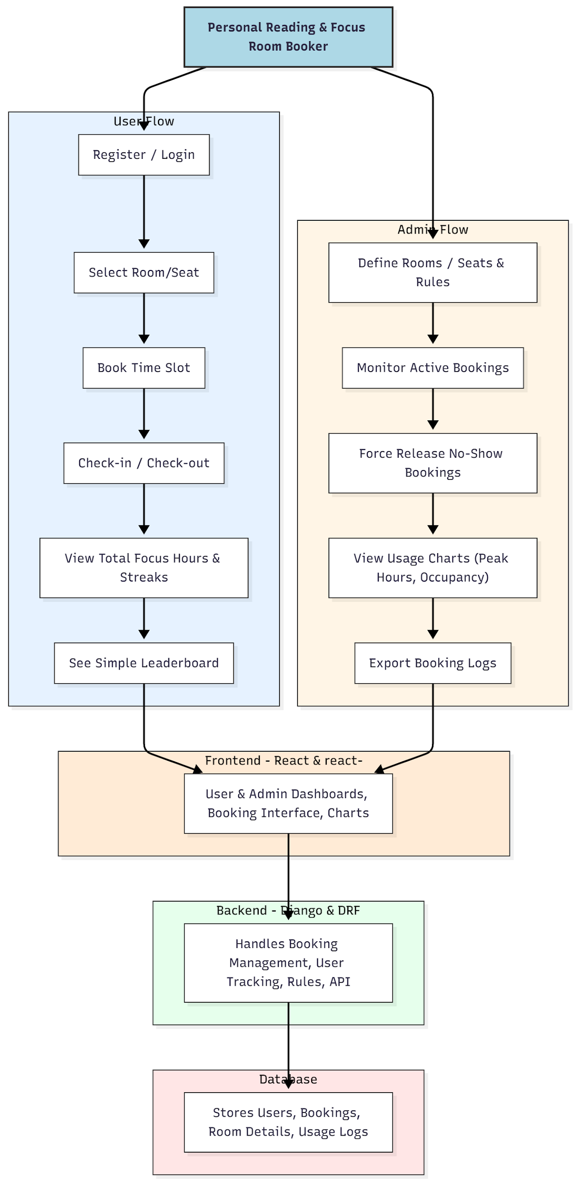

WORKING OF THE PROJECT:
Users register and log in to the portal, select a room or seat, and book a specific time slot for focused study or work. They check in and check out using the interface, which records usage and updates focus hours and streaks. A simple leaderboard motivates engagement and consistency. Administrators define rooms, seats, and booking rules, monitor active sessions, release no-shows, and view occupancy charts. Usage logs can be exported for record-keeping. The backend handles all booking logic, data storage, and API requests, while the frontend provides an interactive dashboard for both users and admins, ensuring efficient and transparent management..

SOFTWARE REQUIREMENT:
- Backend:
  - Python 3.x
  - Django
  - Django REST Framework
  - SQLite/PostgreSQL
- Frontend:
  - Node.js and npm
  - React.js
  - Axios
- Development Tools:
  - Visual Studio Code
  - Postman (for testing APIs)
  - Git/GitHub (for version control)
- Server/Deployment (Optional):
  - Gunicorn, Nginx, or Heroku/AWS for hosting

ADVANTAGES OF THE PROJECT:

• Efficient and organized room/seat booking
• Real-time tracking of focus hours and streaks
• Prevents double-bookings and no-shows
• Administrator oversight through dashboards and charts
• Encourages consistent study habits through leaderboard
• Generates usage analytics and exportable logs
• Scalable for libraries, study halls, or co-working spaces
• Enhances user experience and operational efficiency

APPLICATIONS OF THE PROJECT:
• College and university libraries
• Study halls and co-working spaces
• Corporate silent rooms
• Training centers and reading rooms
• Any institution requiring managed focus areas

REFERENCES:

- Django REST Framework Documentation — Django Software Foundation. Django Documentation. Available: https://docs.djangoproject.com/
- Django REST Framework. DRF Documentation. Available: https://www.django-rest-framework.org/
- React. React Official Documentation. Available: https://reactjs.org/docs/getting-started.html
- Redux. Redux Documentation. Available: https://redux.js.org/introduction/getting-started
- PostgreSQL Global Development Group. PostgreSQL Documentation. Available: https://www.postgresql.org/docs/
- MySQL. MySQL Reference Manual. Available: https://dev.mysql.com/doc/
- Git. Git Documentation. Available: https://git-scm.com/doc
- Node.js. Node.js Documentation. Available: https://nodejs.org/en/docs/
- Axios. Axios Documentation. Available: https://axios-http.com/docs/intro
- Socket.io Documentation – https://socket.io/docs/

